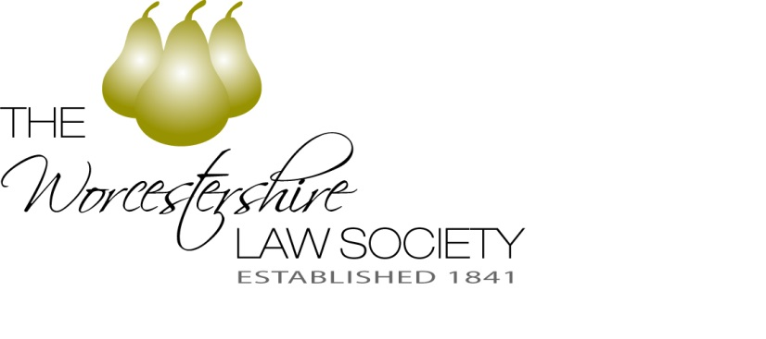
Legal Awards 2018
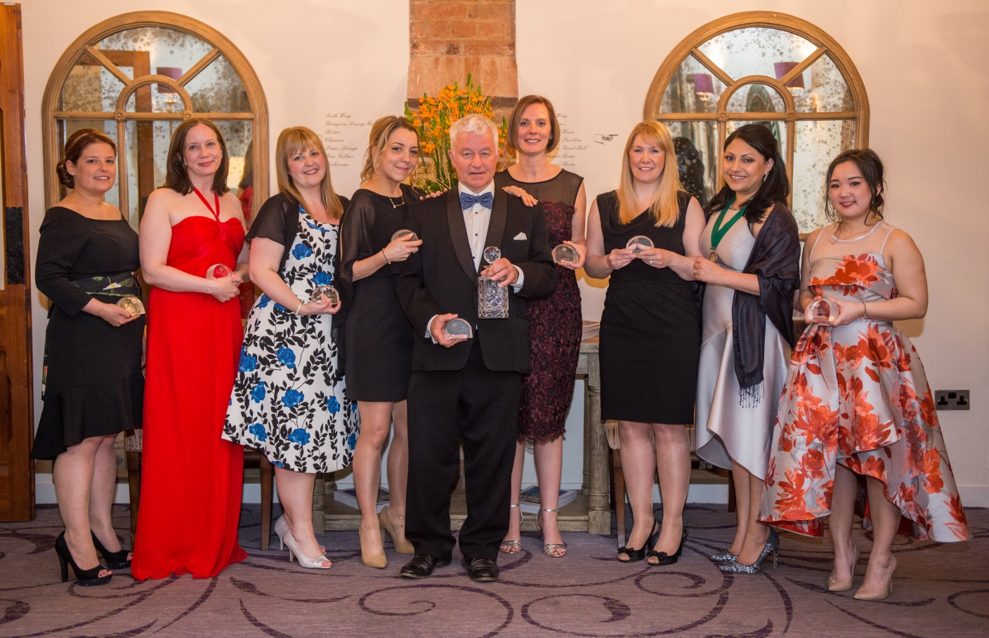
2017 Winners
Nominations for Legal Awards 2018
…..celebrating firms and individuals across
Worcestershire
After four years of worthy winners and fantastic evenings, the search is now on to find the winners of Worcestershire Law Society’s Legal Awards 2018.

Do you or someone you work with or a barrister you regularly instruct deserve recognition for the work you/they accomplish? Are you particularly motivated or inspired by someone or do you recognise extraordinary qualities in another? If so, Worcestershire Law Society would like to hear from you.

Entries are now open from individuals and firms across the county to nominate themselves, a colleague or practice in any or all of the categories. Our panel of judges from the profession, academia and business will interview shortlisted nominees on Friday 9th March 2018 and winners will be announced at the awards ceremony on Friday 27th April 2018 at The Guildhall, Worcester.

2018 Legal Awards Categories

Trainee Solicitor of the Year
***
Junior Solicitor of the Year
***
Solicitor of the Year
***
Barrister of the Year
***
Best Support Staff (three awards)
Paralegal
Administration
Office Management
***
Professional Discipline: Commercial Property
Follow these guidelines to submit your nominations
Step one:
- Nominate the name of ONE individual or firm in each of the seven listed categories. Only individuals or firms in practice in Worcestershire are eligible to enter.
- When nominating an individual or firm, consider their professionalism, reputation, expertise and commitment to those they represent including any involvement for the benefit of the wider community.
- The definition of “junior solicitor of the year” to be newly qualified and solicitors with less than 5 years’active PQE
- Nominations should be legible, include a supporting statement as to why the individual or firm has been nominated in a specific category and include the name of your firm. Incomplete nominations will not be accepted.
- The closing date for nominations is Friday 26th January 2018.
- Nominations received after Friday 26th January 2018 will not be accepted.
- The judging panel will consider all nominations received by the closing date and draw up a final shortlist of nominees, who will be invited to attend an interview on Friday 9th March 2018.
- Category winners will be announced at the Legal Awards Dinner taking place on Friday 27th April 2018 at The Guild Hall, Worcester.
- Nominations can be returned to Honorary Secretary – Priya Tromans – Harrison Clark Rickerbys Ltd., 5 Deansway, Worcester, Worcestershire, WR1 2JG by Friday 26th January 2018. T: 01905 744 832 M: 07715 060 364 Email: ptromans@hcrlaw.com DX 716260 Worcester.

